# RAP-06-RAP-Development-Simple List Report

<https://youtu.be/nGIY0GABOso?list=PLqz8SLrkjv2iwPtPRJ4V6zJRfgNrgZKlQ>

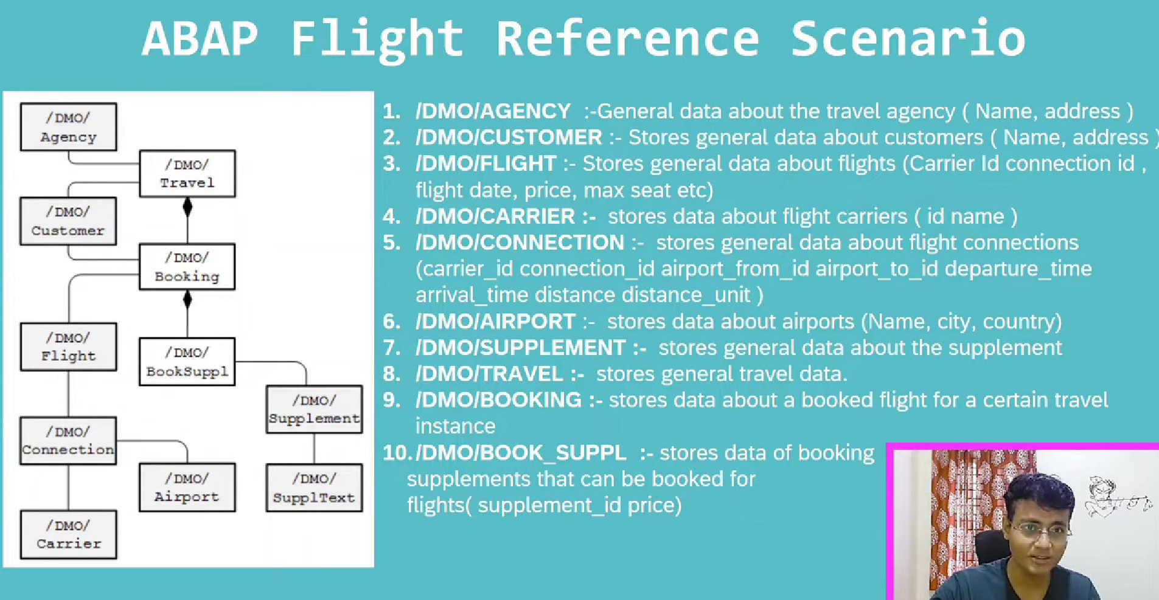

/DMO/Agency, /DMO/CUSTOMER, /DMO/Flight, /DMO/Connection, /DMO/Carrier, /DMO/Airport, /DMO/Supplement, /DMO/SupplText – are master

Above tables are available in on cloud only.

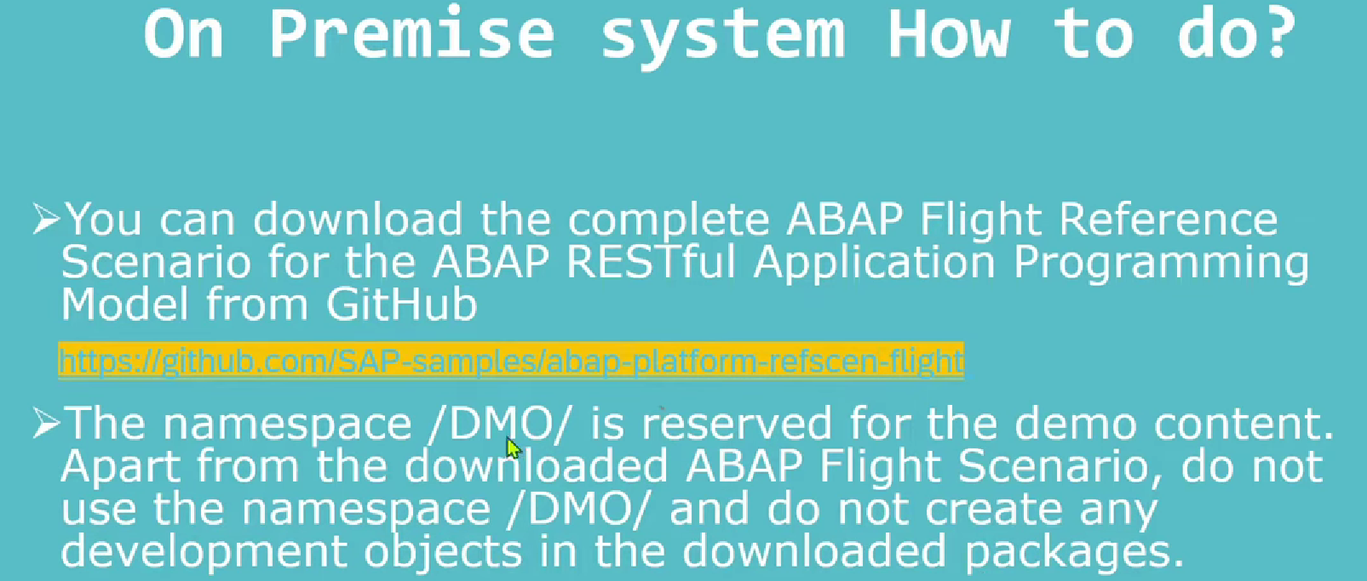 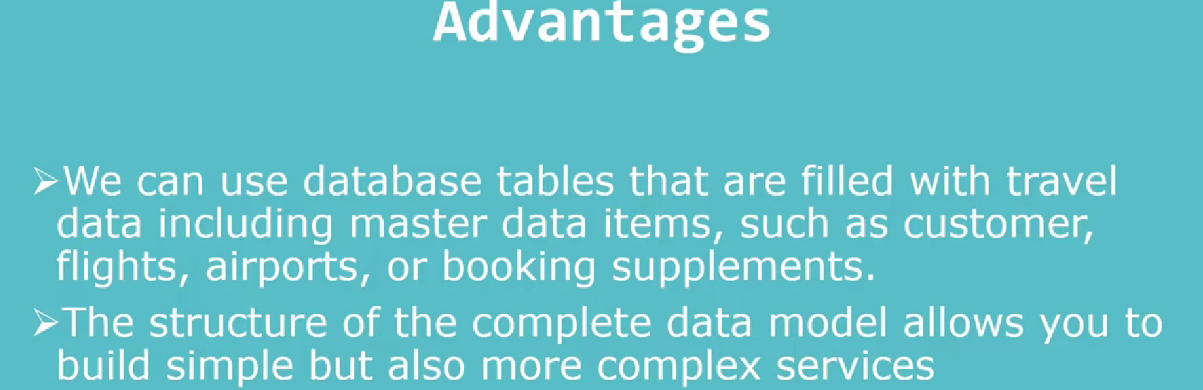

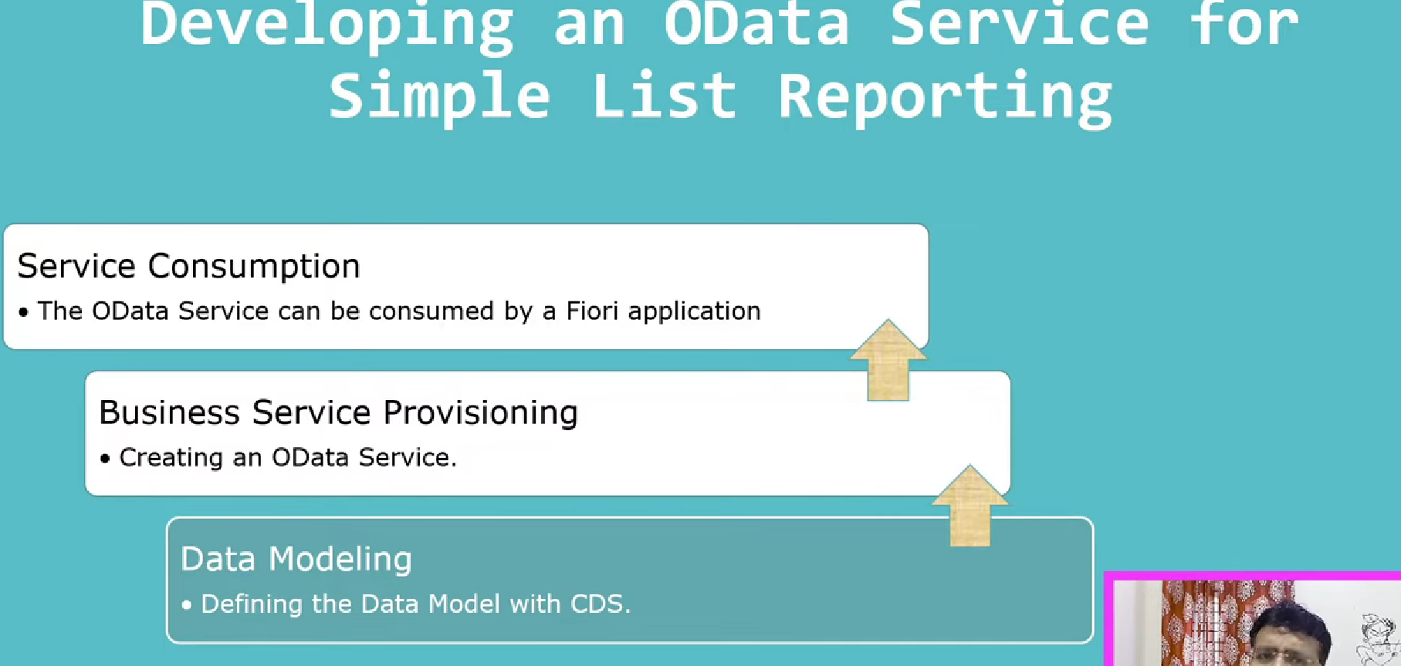

## Development-1

### Tables:

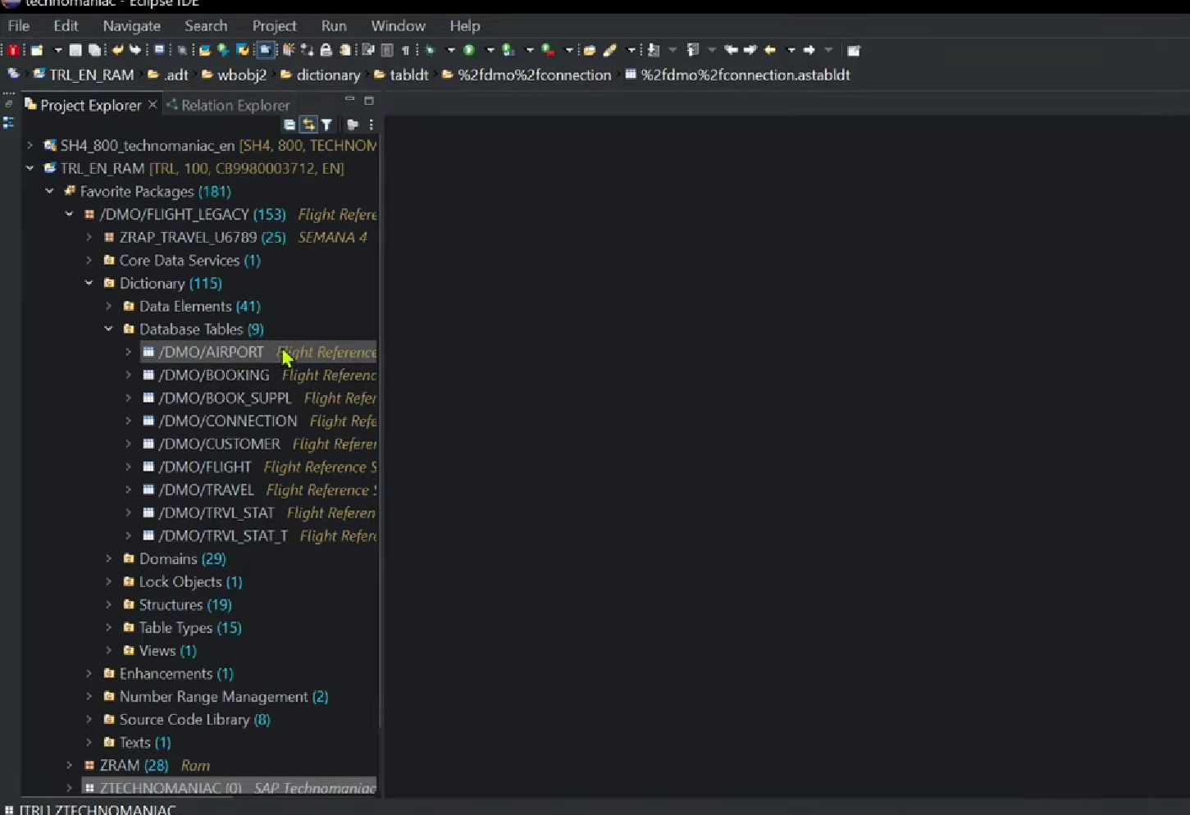

Develop simple list report to display entire data from /DMO/CONNECTION

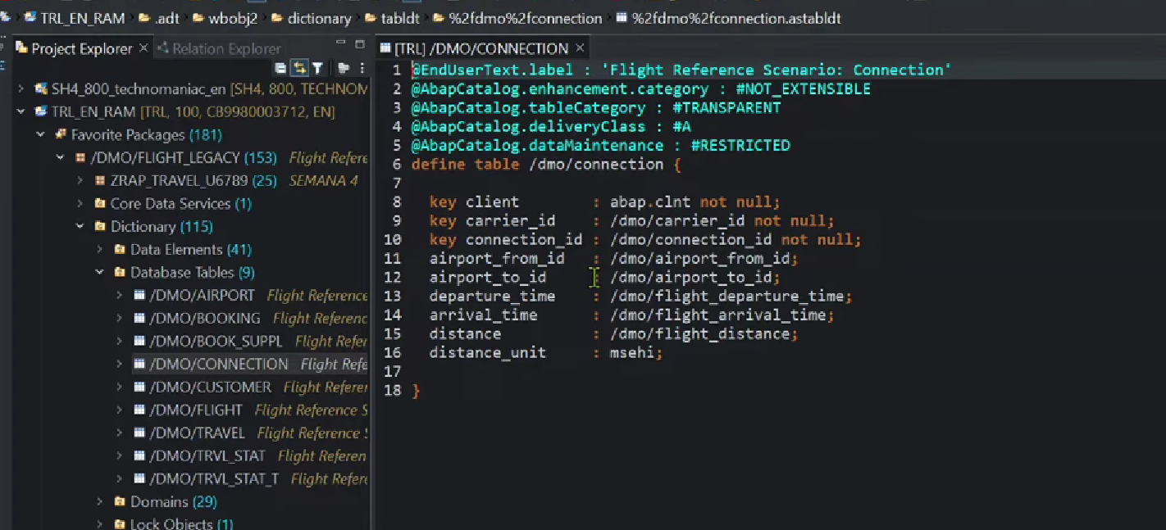

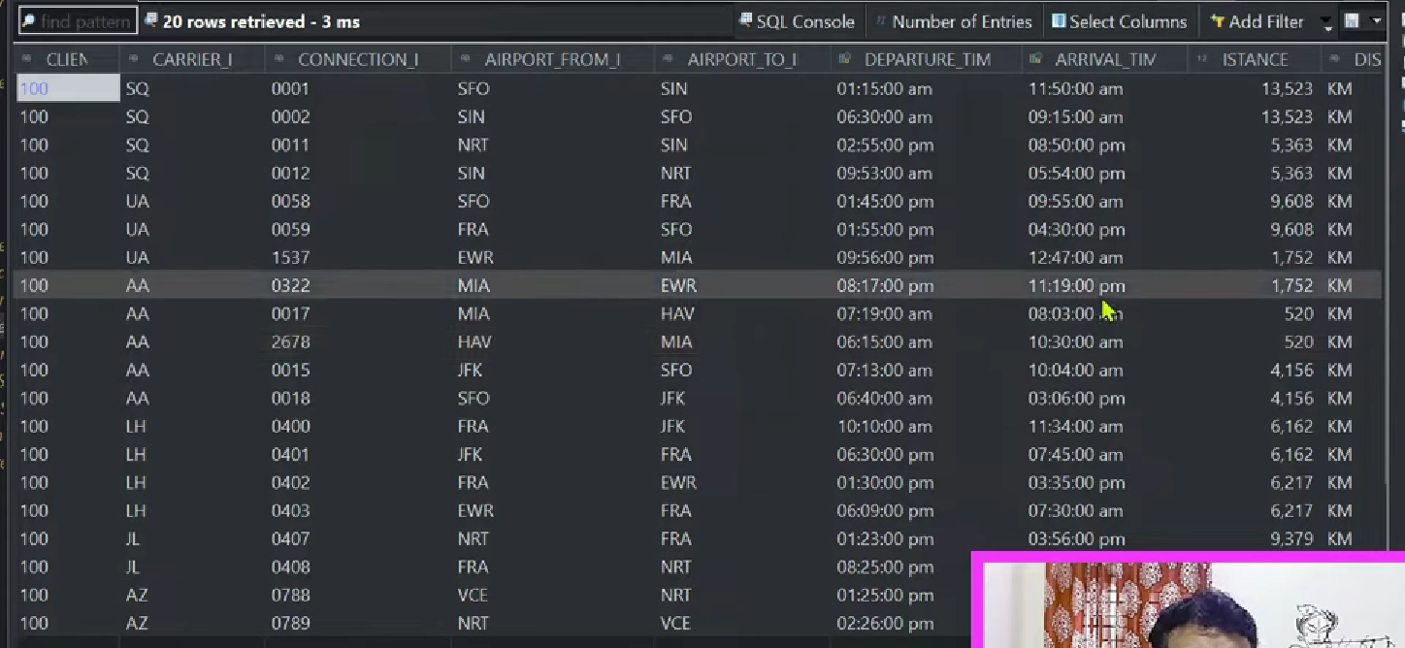

### Create the Interface cds view

For this

1. Right click on the table((/DMO/CONNECTION) 🡪 select the data source.
2. Create the basic data m

odel. Data model is CDS in rap model. 🡪 Create the CDS view on top of table. i.e interface CDS view i.e first layer of the CDS view.

CDS View name: ZI_CONNECTION_TECHNOMONIAC.

1. SAVE it in TR.
2. Select the template as -Define entity – (note -DDIC based CDS view – obsolete from 7.57)

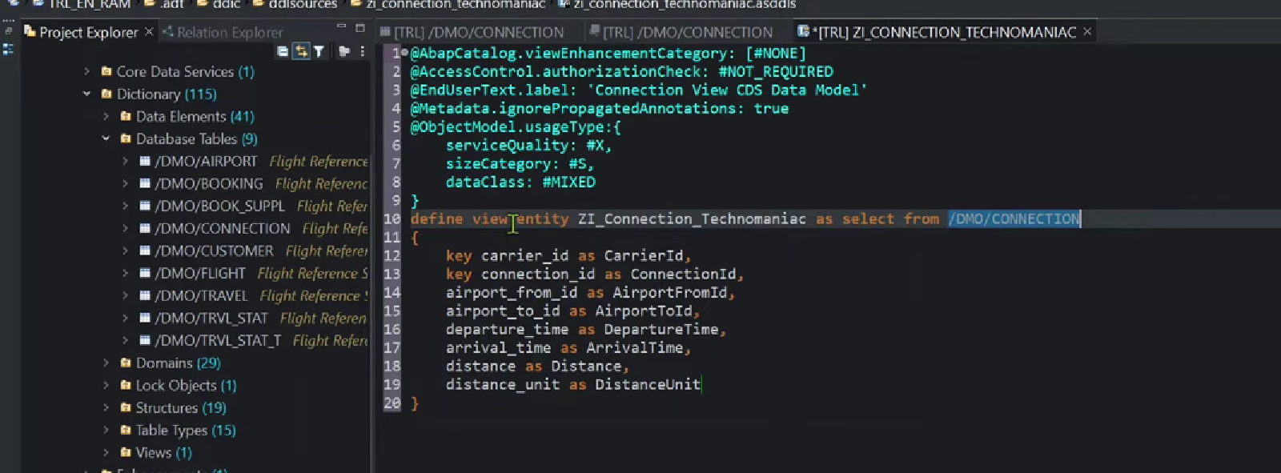

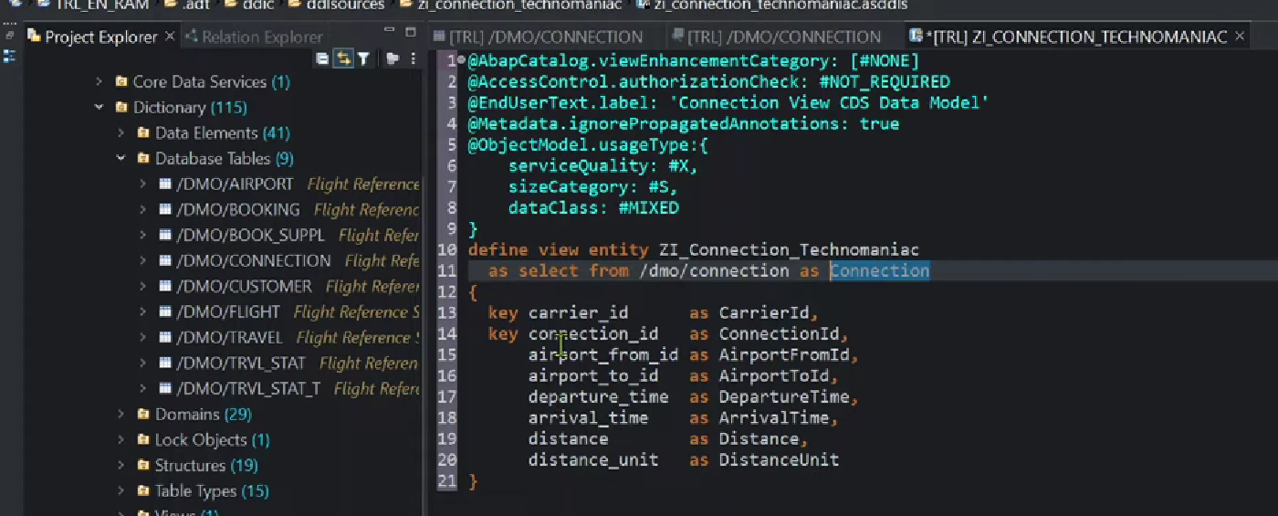

Semantics added for UOM.

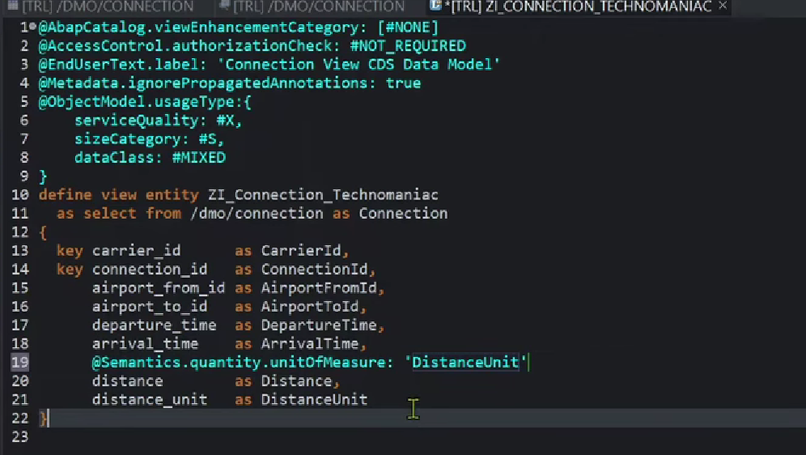

1. CDS entity created.

Pretty pinter- shift + F1

F8 -run object

1. F8-get the output.

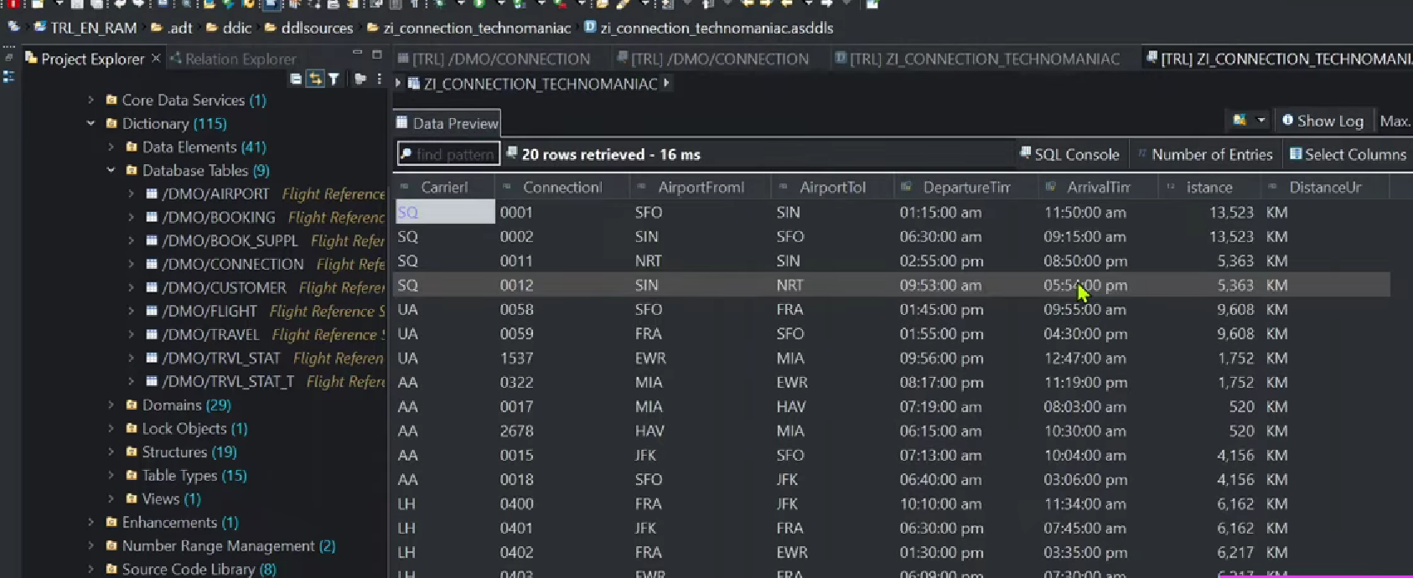

Now create the service definitions.

### Service definitions:

Use: what all are the CDS entities we want to consume for particular ODATA services.

1. Right click on particular cds View(ZI_CONNECTION_TECHNOMANIAC) 🡪Click on New service Definition.
2. Service definition name- ZFLIGHT_TECHNOMANIAC.
3. SAVe under the tr.
4. In next screen, select the define the service option
5. Click on finish.

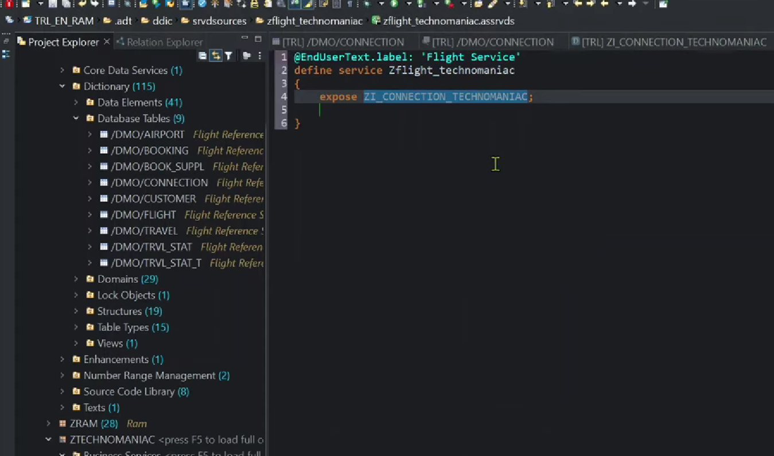

Service definition has been created.

Activate it – ctrl + f3.

Once create the service definition, then create the service binding.

### Service Binding:

To create the service binding,

1. Right click on service definition 🡪 select new service binding option.

And provide the service binding name – ZUI_FLIGHT_TECHNOMANIAC_V2( means ODATA V2- UI)

And choose the service binding type – for UI/Web API- choose- OData V2-UI - it is mandatory

Odata v2- web Api- consumed in other web apps.

Service Defintion- ZFLIGHT_TECHNOMANIAC- it is mandatory

1. Save under the tr.
2. Click on finish button.
3. Next screen.

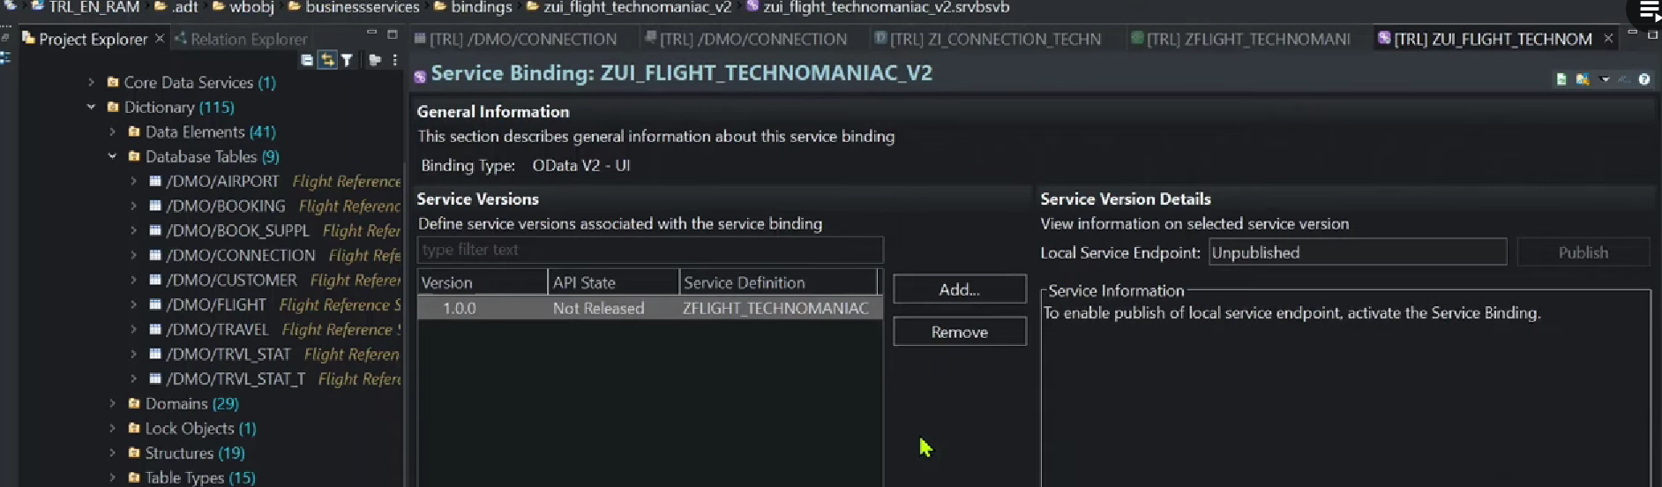

Service binding got created. And by default – unpublished.

Note : particular service, we can create multiple service binding as well we will see in upcoming class.

1. Ctrl+f3 activate the service binding.
2. Once activated the service binding, then publish the service binding.

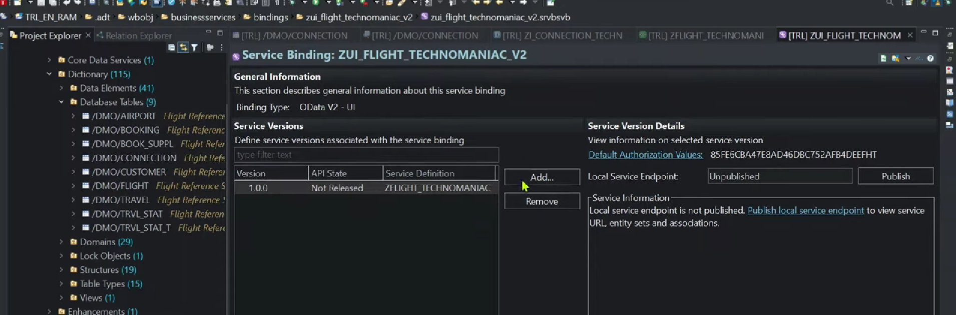

Now status is unpublished then click on publish button.

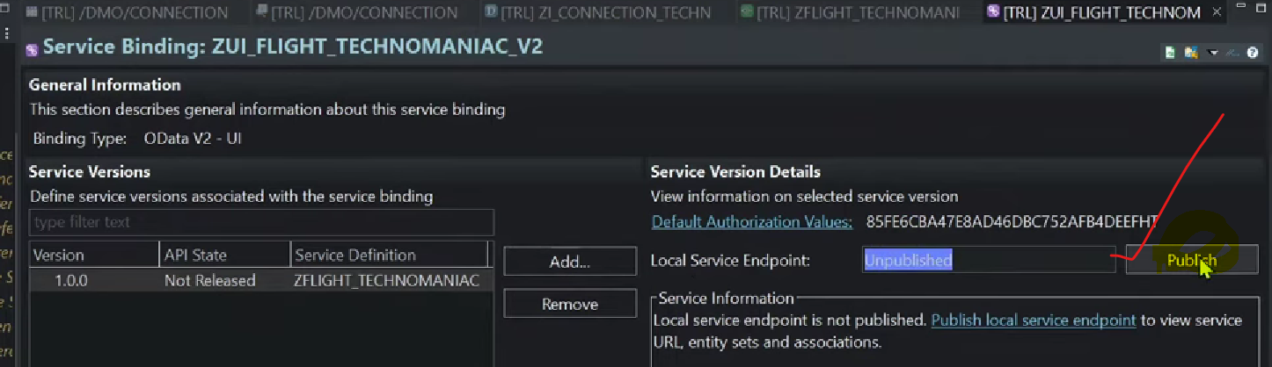

Once click on the publish button, you can able to see the service over here.

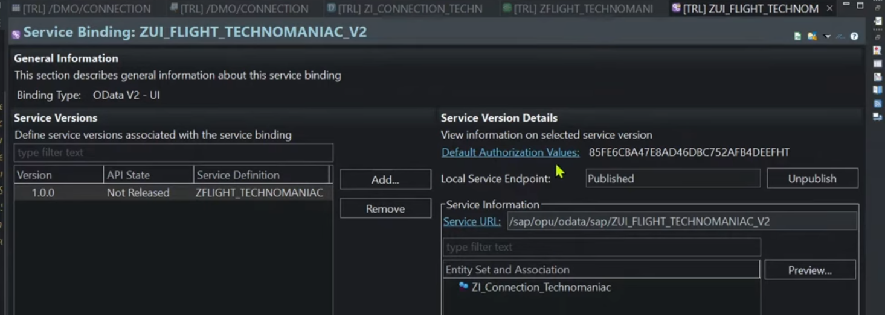

Finally service has published.

1. Here we can see the service status.- published.
2. I want to see the service url- click on service url button- it will show the service.

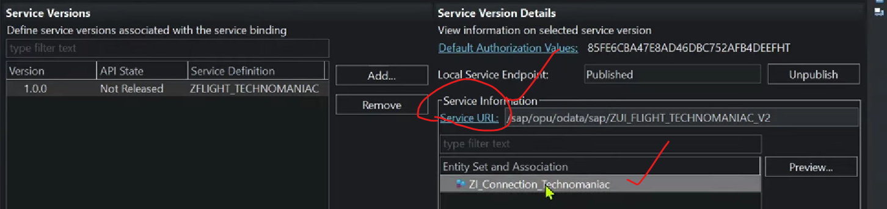

Once click in it.

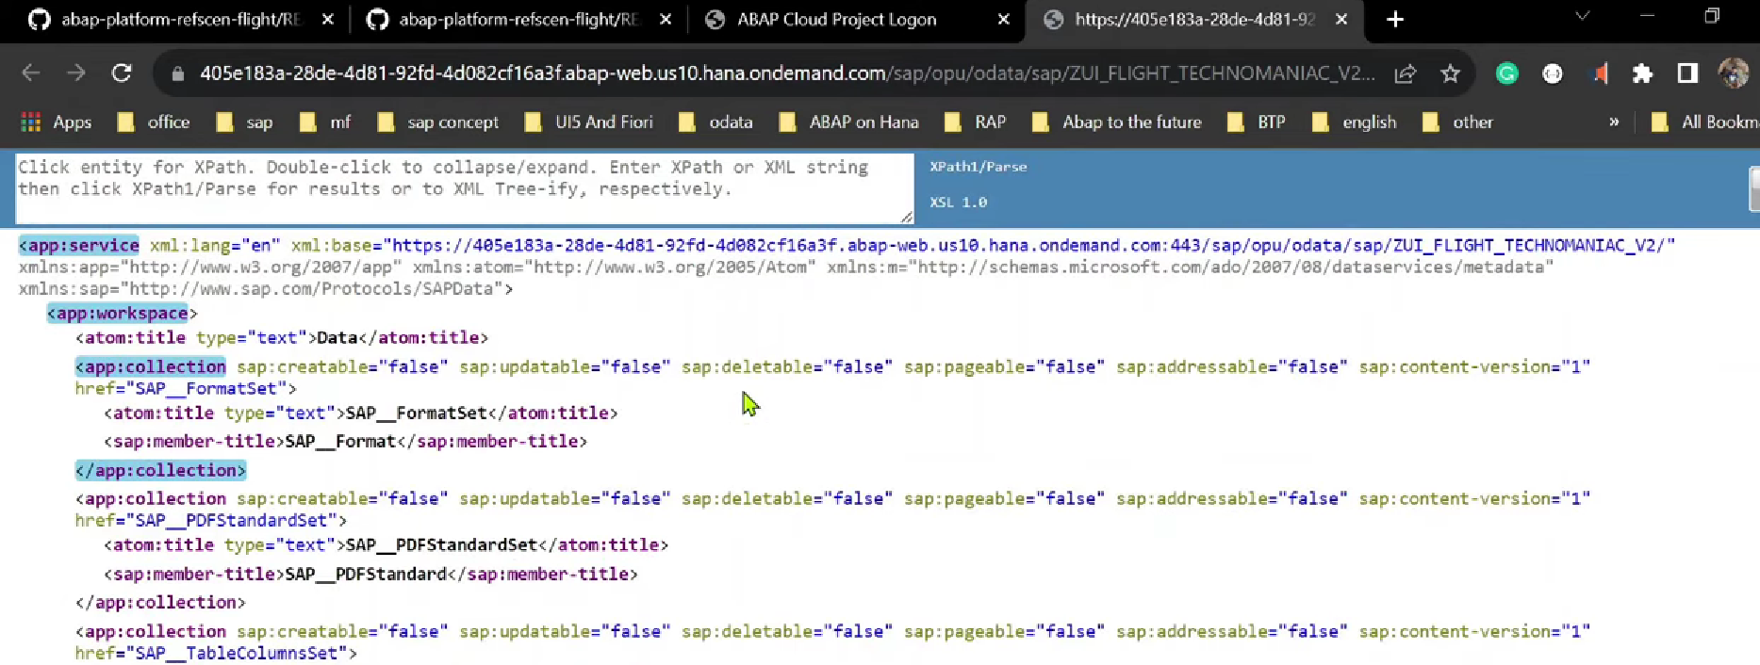

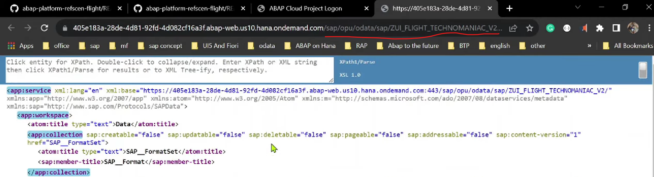

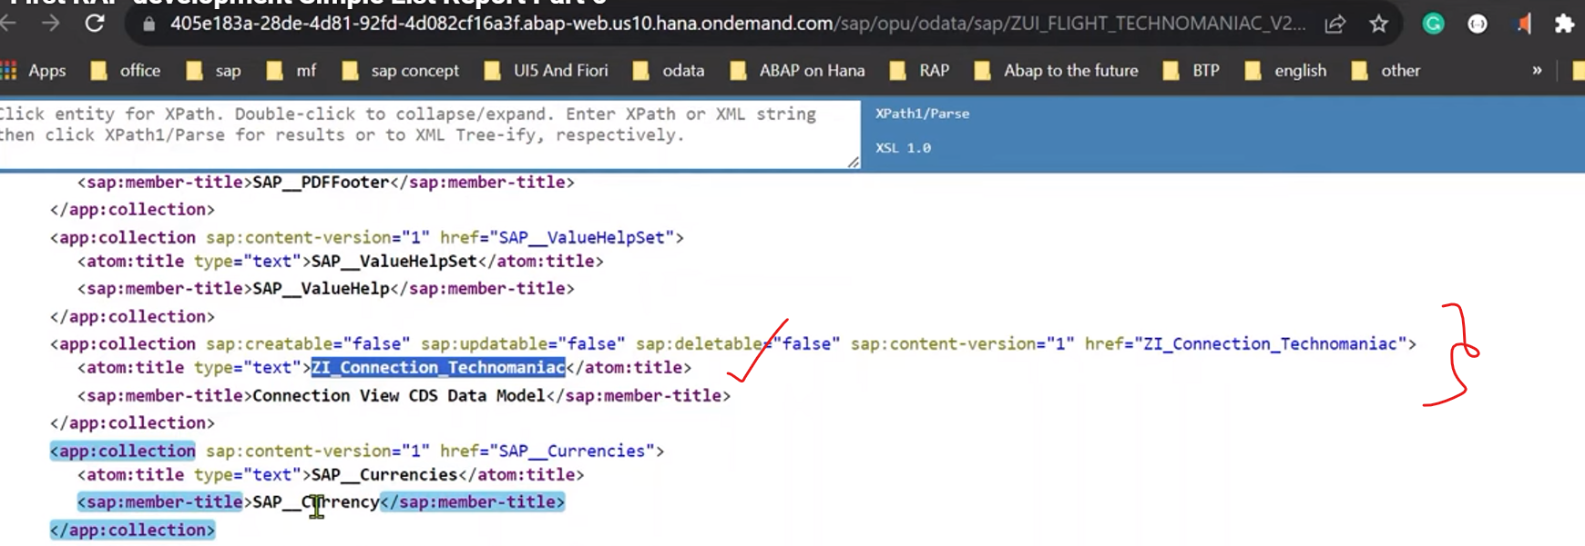

Along with this entity, we have seen other entity set also those are generated by SADL it self.

Service path: /sap/opu/odata/sap/<servicename>…

1. One entity over here for this services.

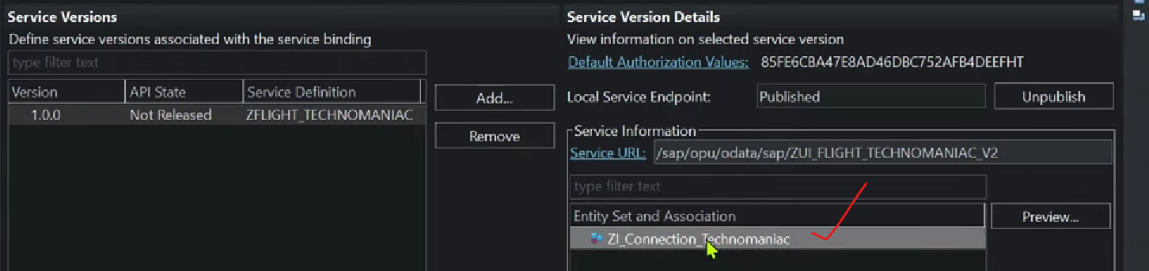

1. Metadata of this service.

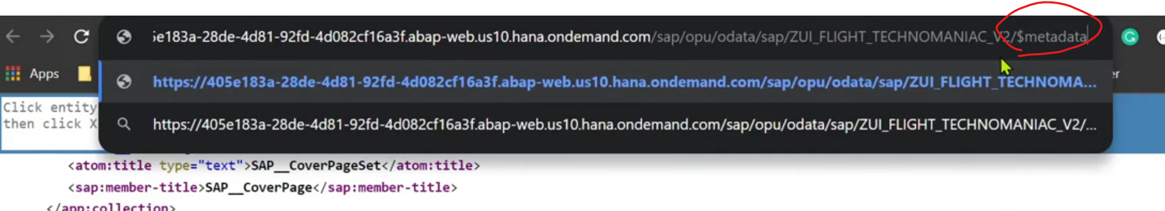

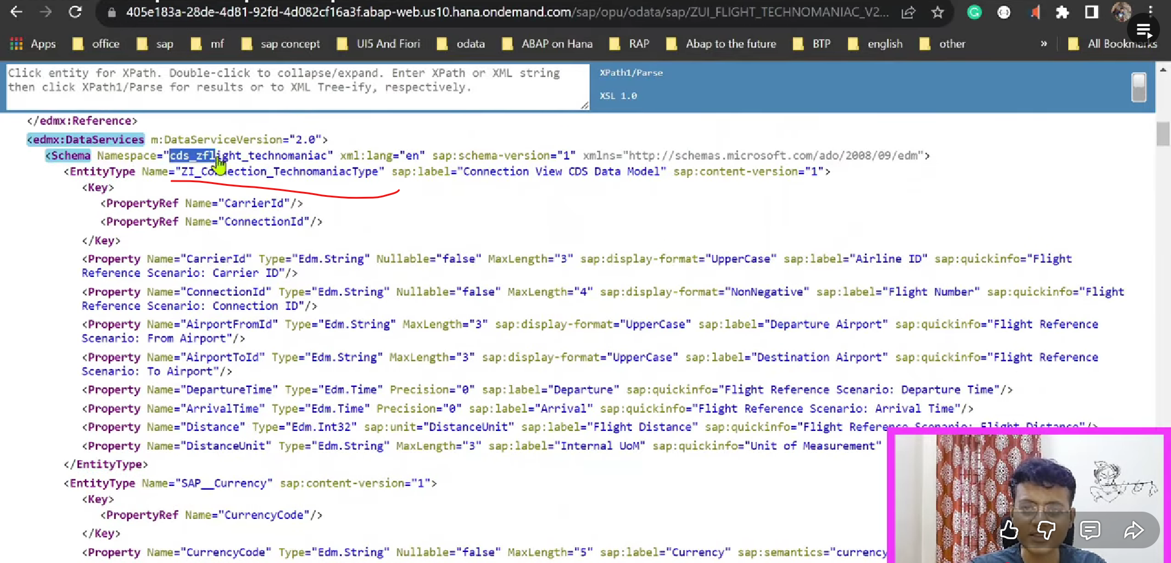

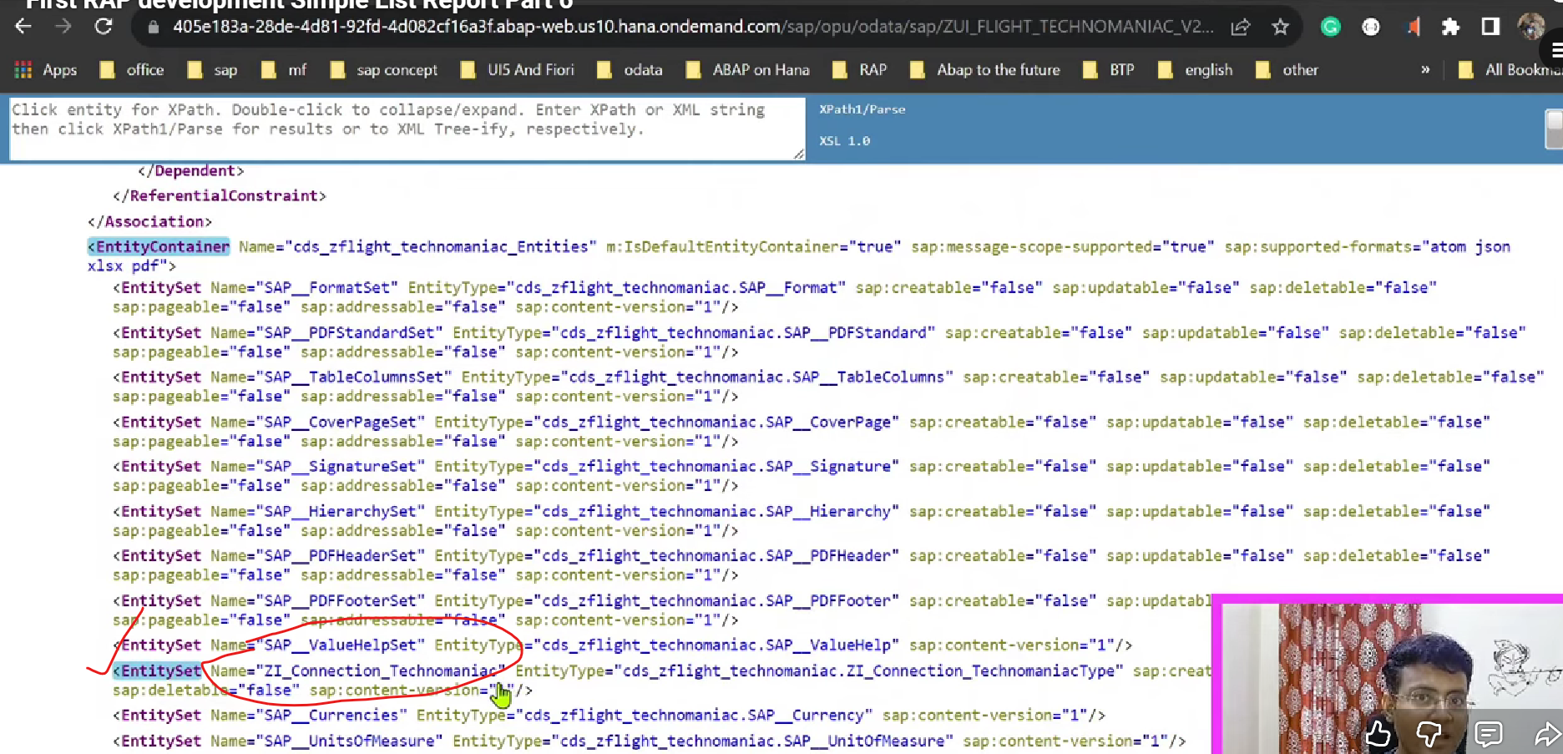

In meta data cds view name appears.

1. CDS view name - CDS_<CDS View name>
2. Entity Tyoe - <Interface view name>Type
3. EntitSet- - <Exposed view name at service definition>, here entity type – is the combination of <cdsname>.<enitytype>.
4. Whatever SADL has generated default enity types those are useful in front end. Because download data from the excel.. etc.. like ALV grid functionality providing at ui level.

Once Mettdata displayed. Now we will see the preview of the applications.

1. Click on preview button.

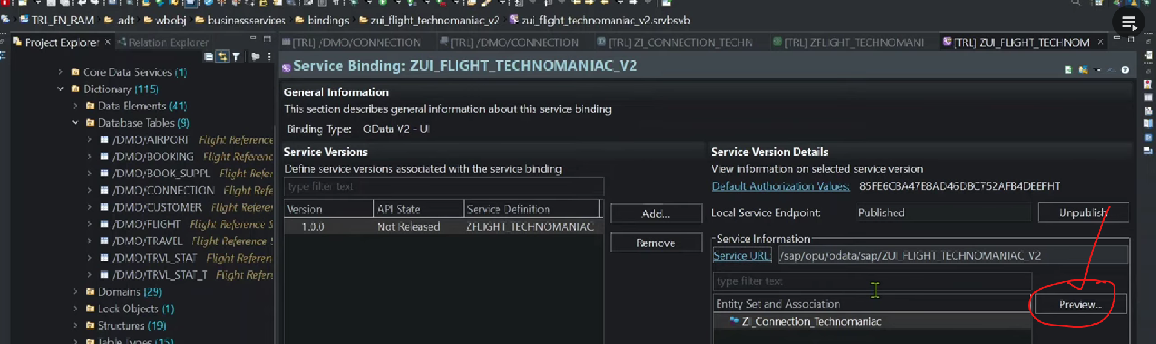

**Or**

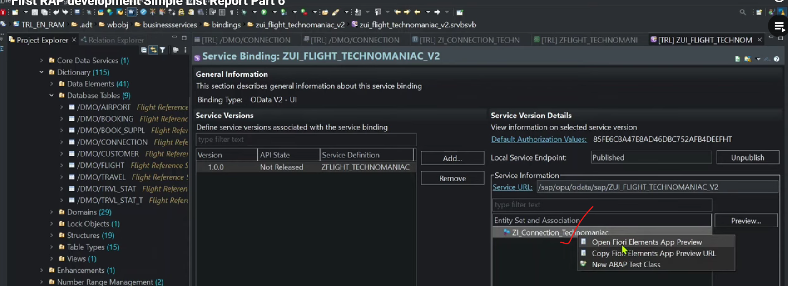

It will automatically preview application overhere.

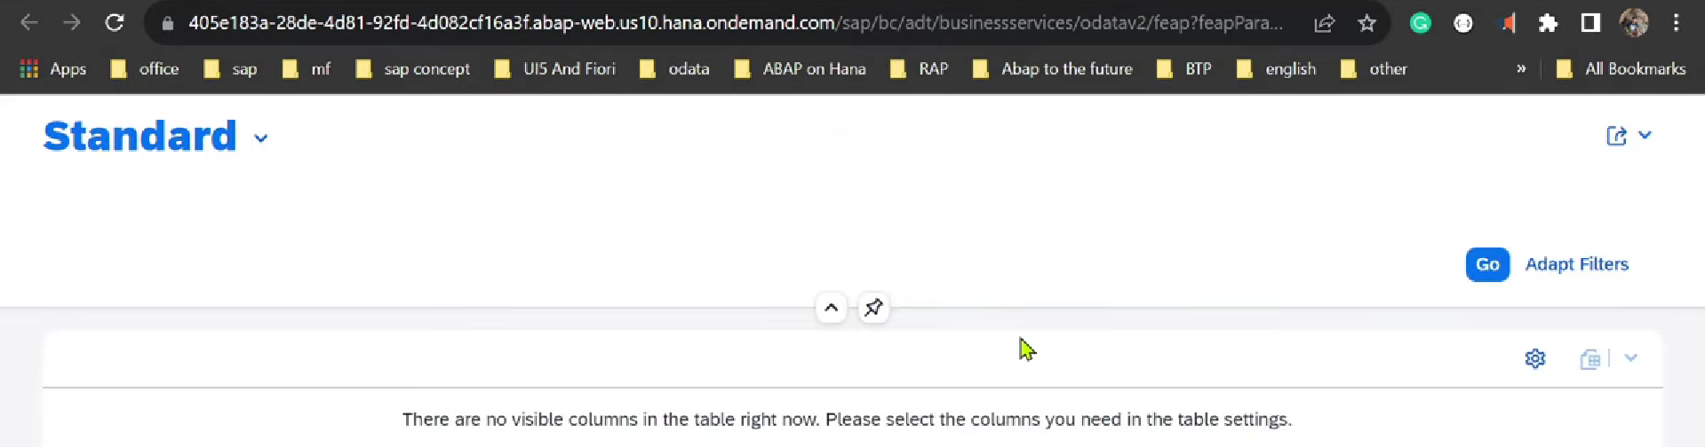

Select all the fields from settings button.

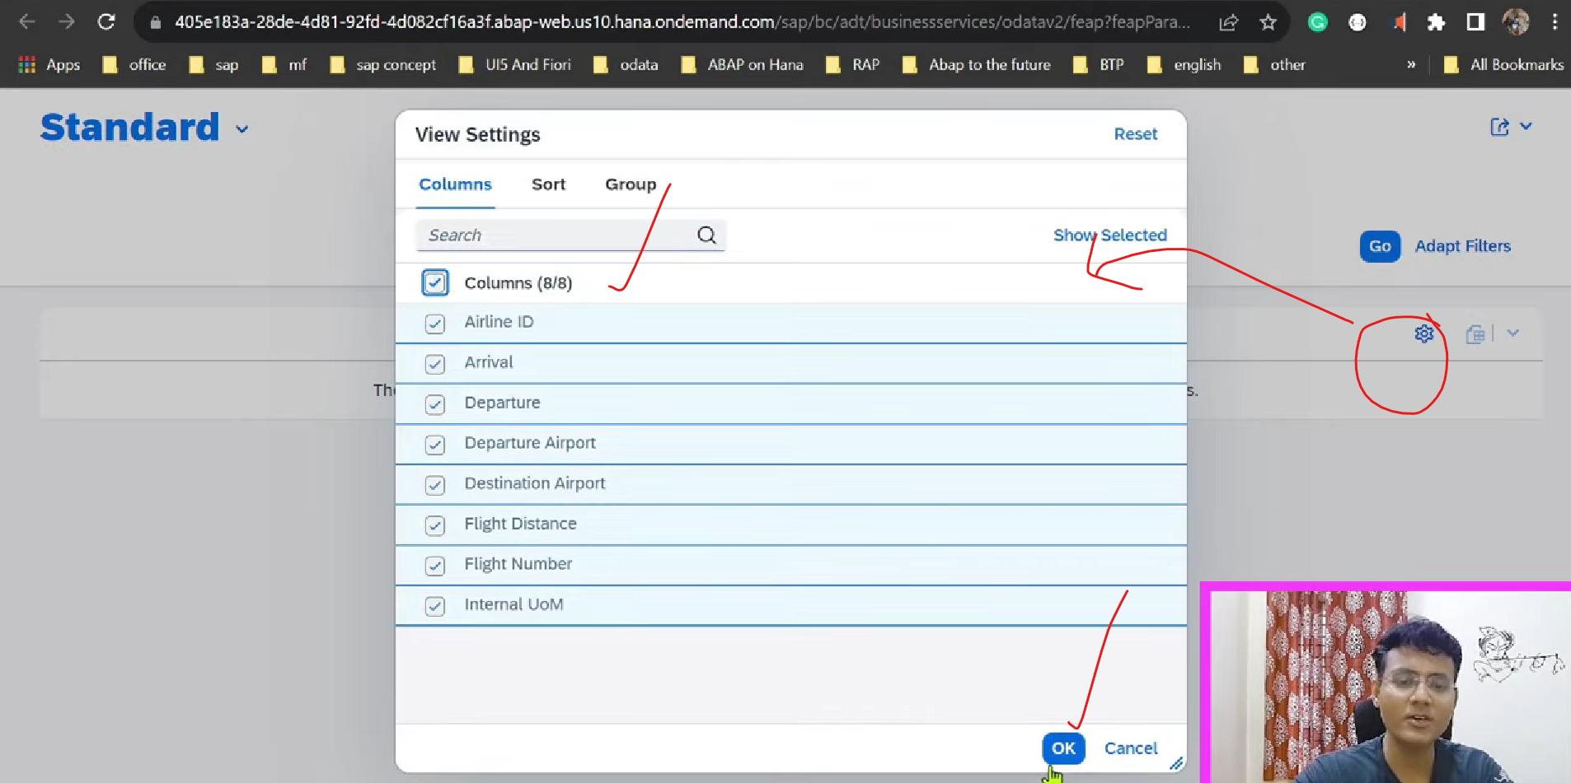

Click on GO button.

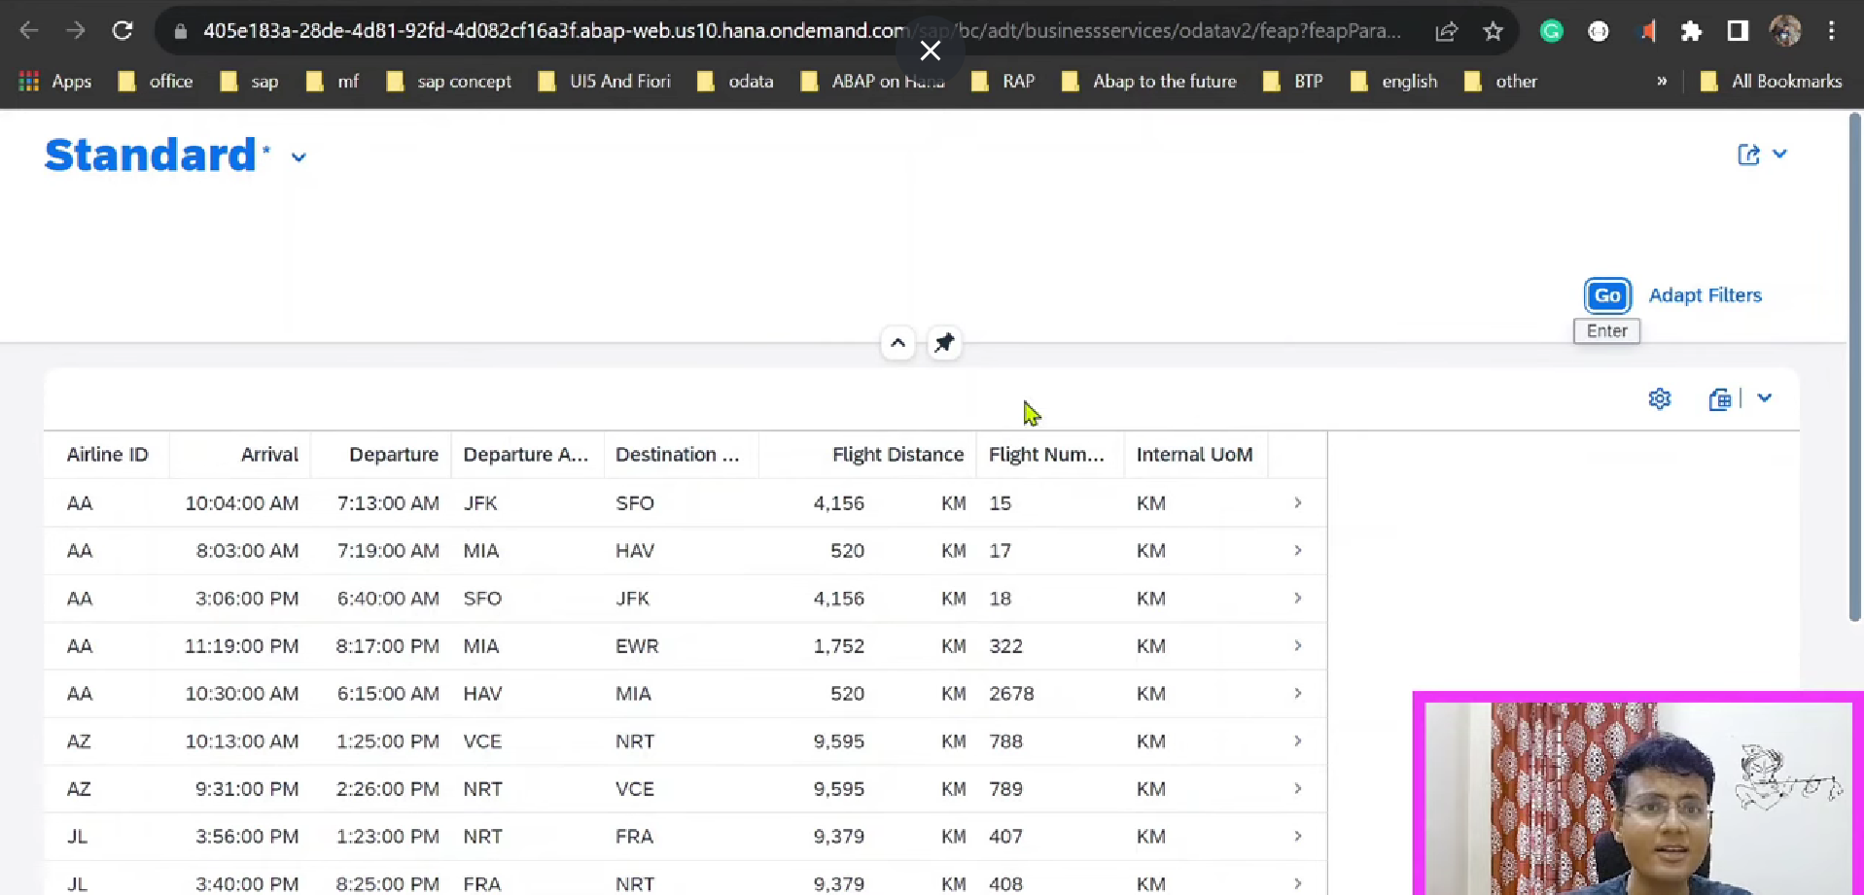

These data we can export in excel – inbuilt functionality SADL provided.

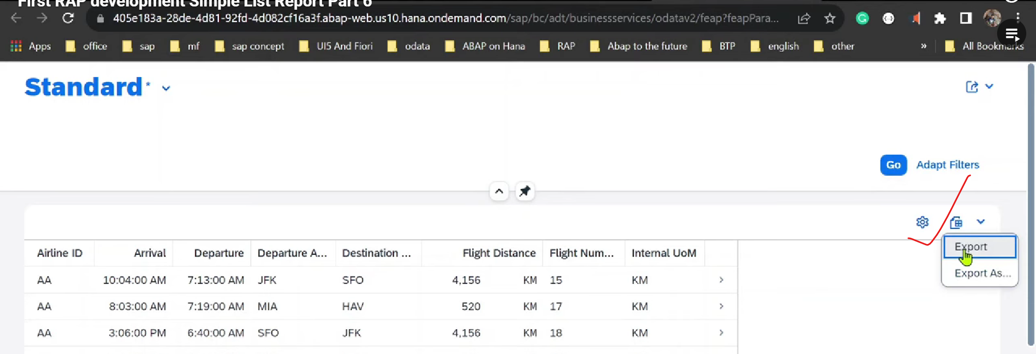

Download into in format of excel/pdf.

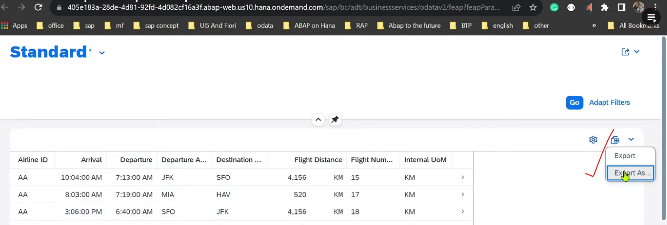

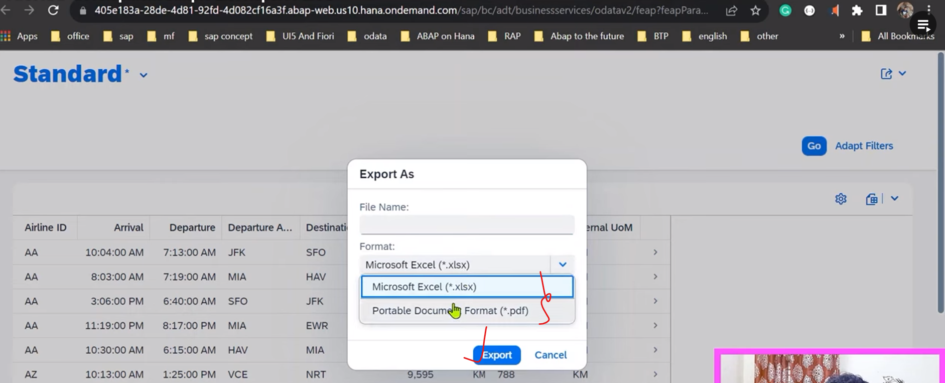

Based on SADL features, other entites are also working for download to excel/ pdf.. etc.

## Semantically dependent elements- Currency/Quantity

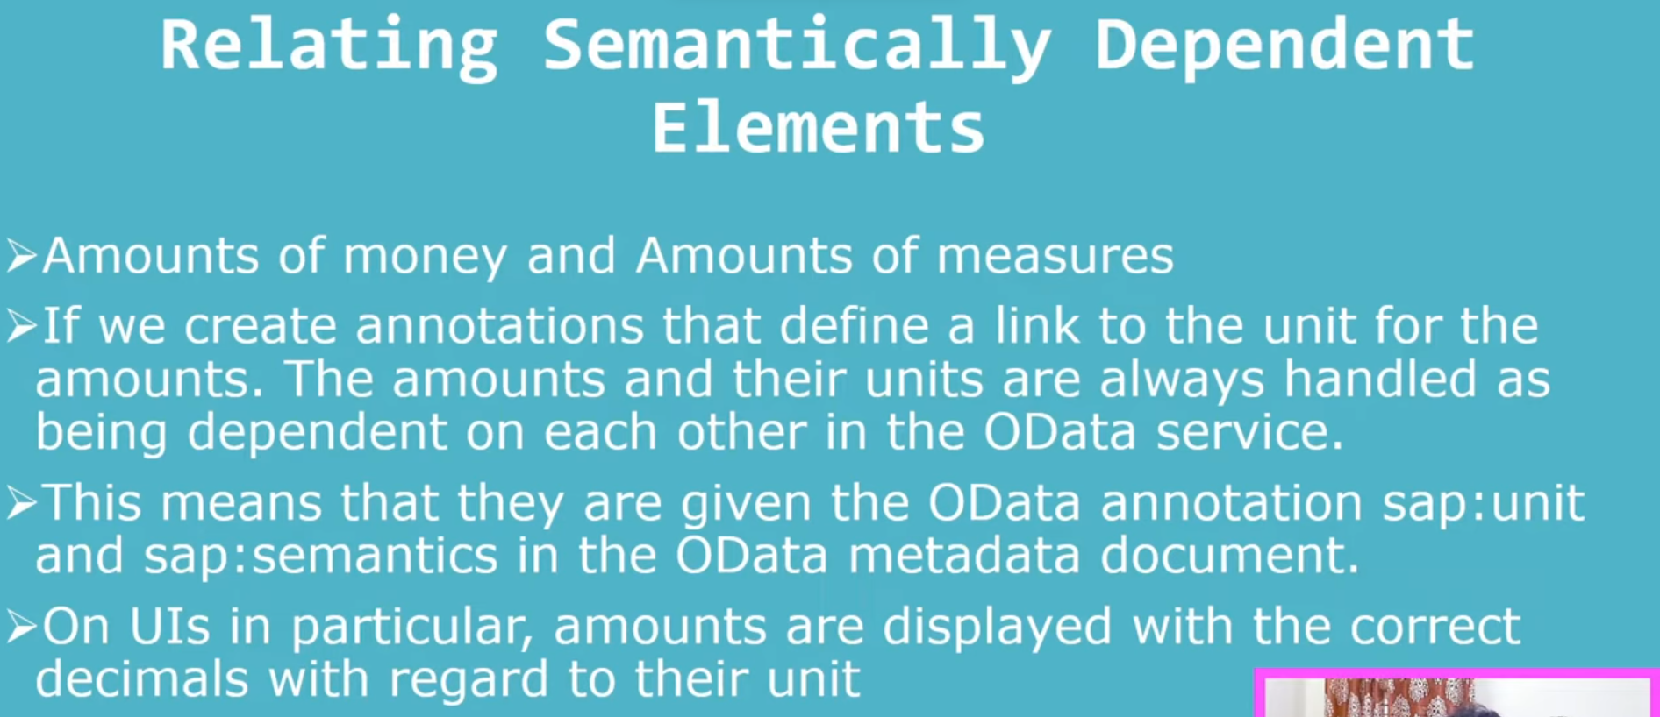

For amount 🡪 there should be currency, based on currency automatically convert the data @UI level.

For Quantity 🡪 there should be UOM.

Need to establish the relation ship between this.

### Annotations:

@Semanatics.quantity.unitOfMeasure : ‘Fieldname’.

@Semantics.unitOfMeasure: true

Fieldname : Fieldname

define view entity Z_MyView

as select from ztable_a as a

association [1..1] to ztable_b as b on a.key = b.key

{

@Semantics.quantity.unitOfMeasure: 'UnitField'

a.quantity_field,

@Semantics.unitOfMeasure: true

b.uom_field as UnitField // Field from another table must be in the list

}